Summer Learning Calendar

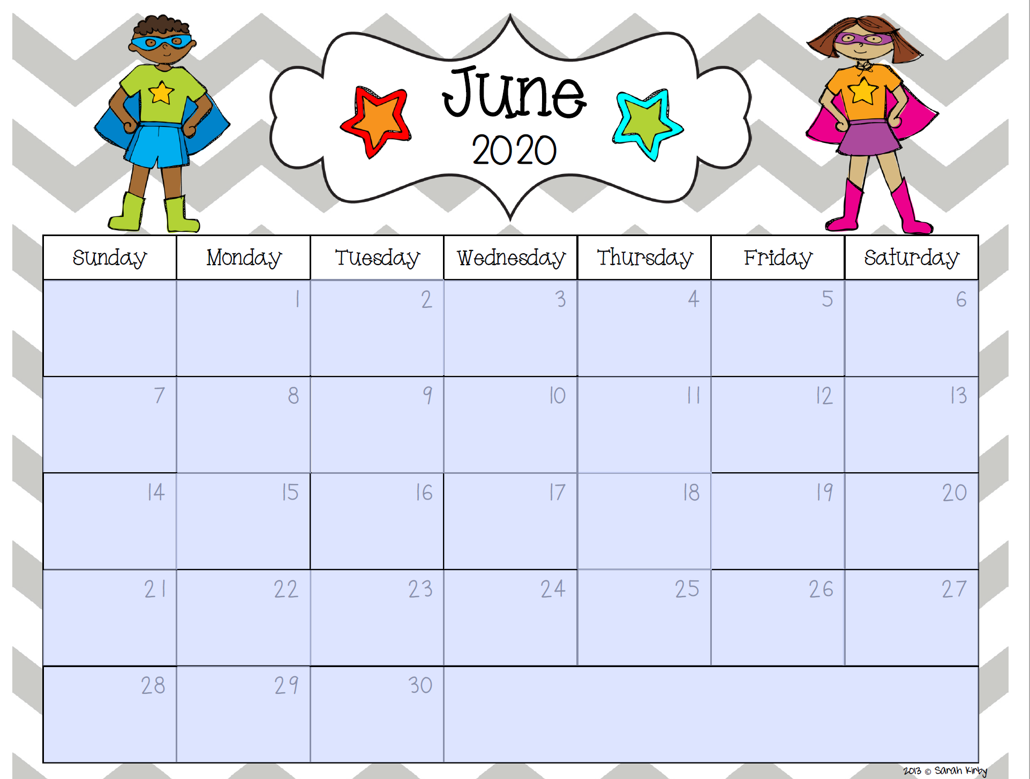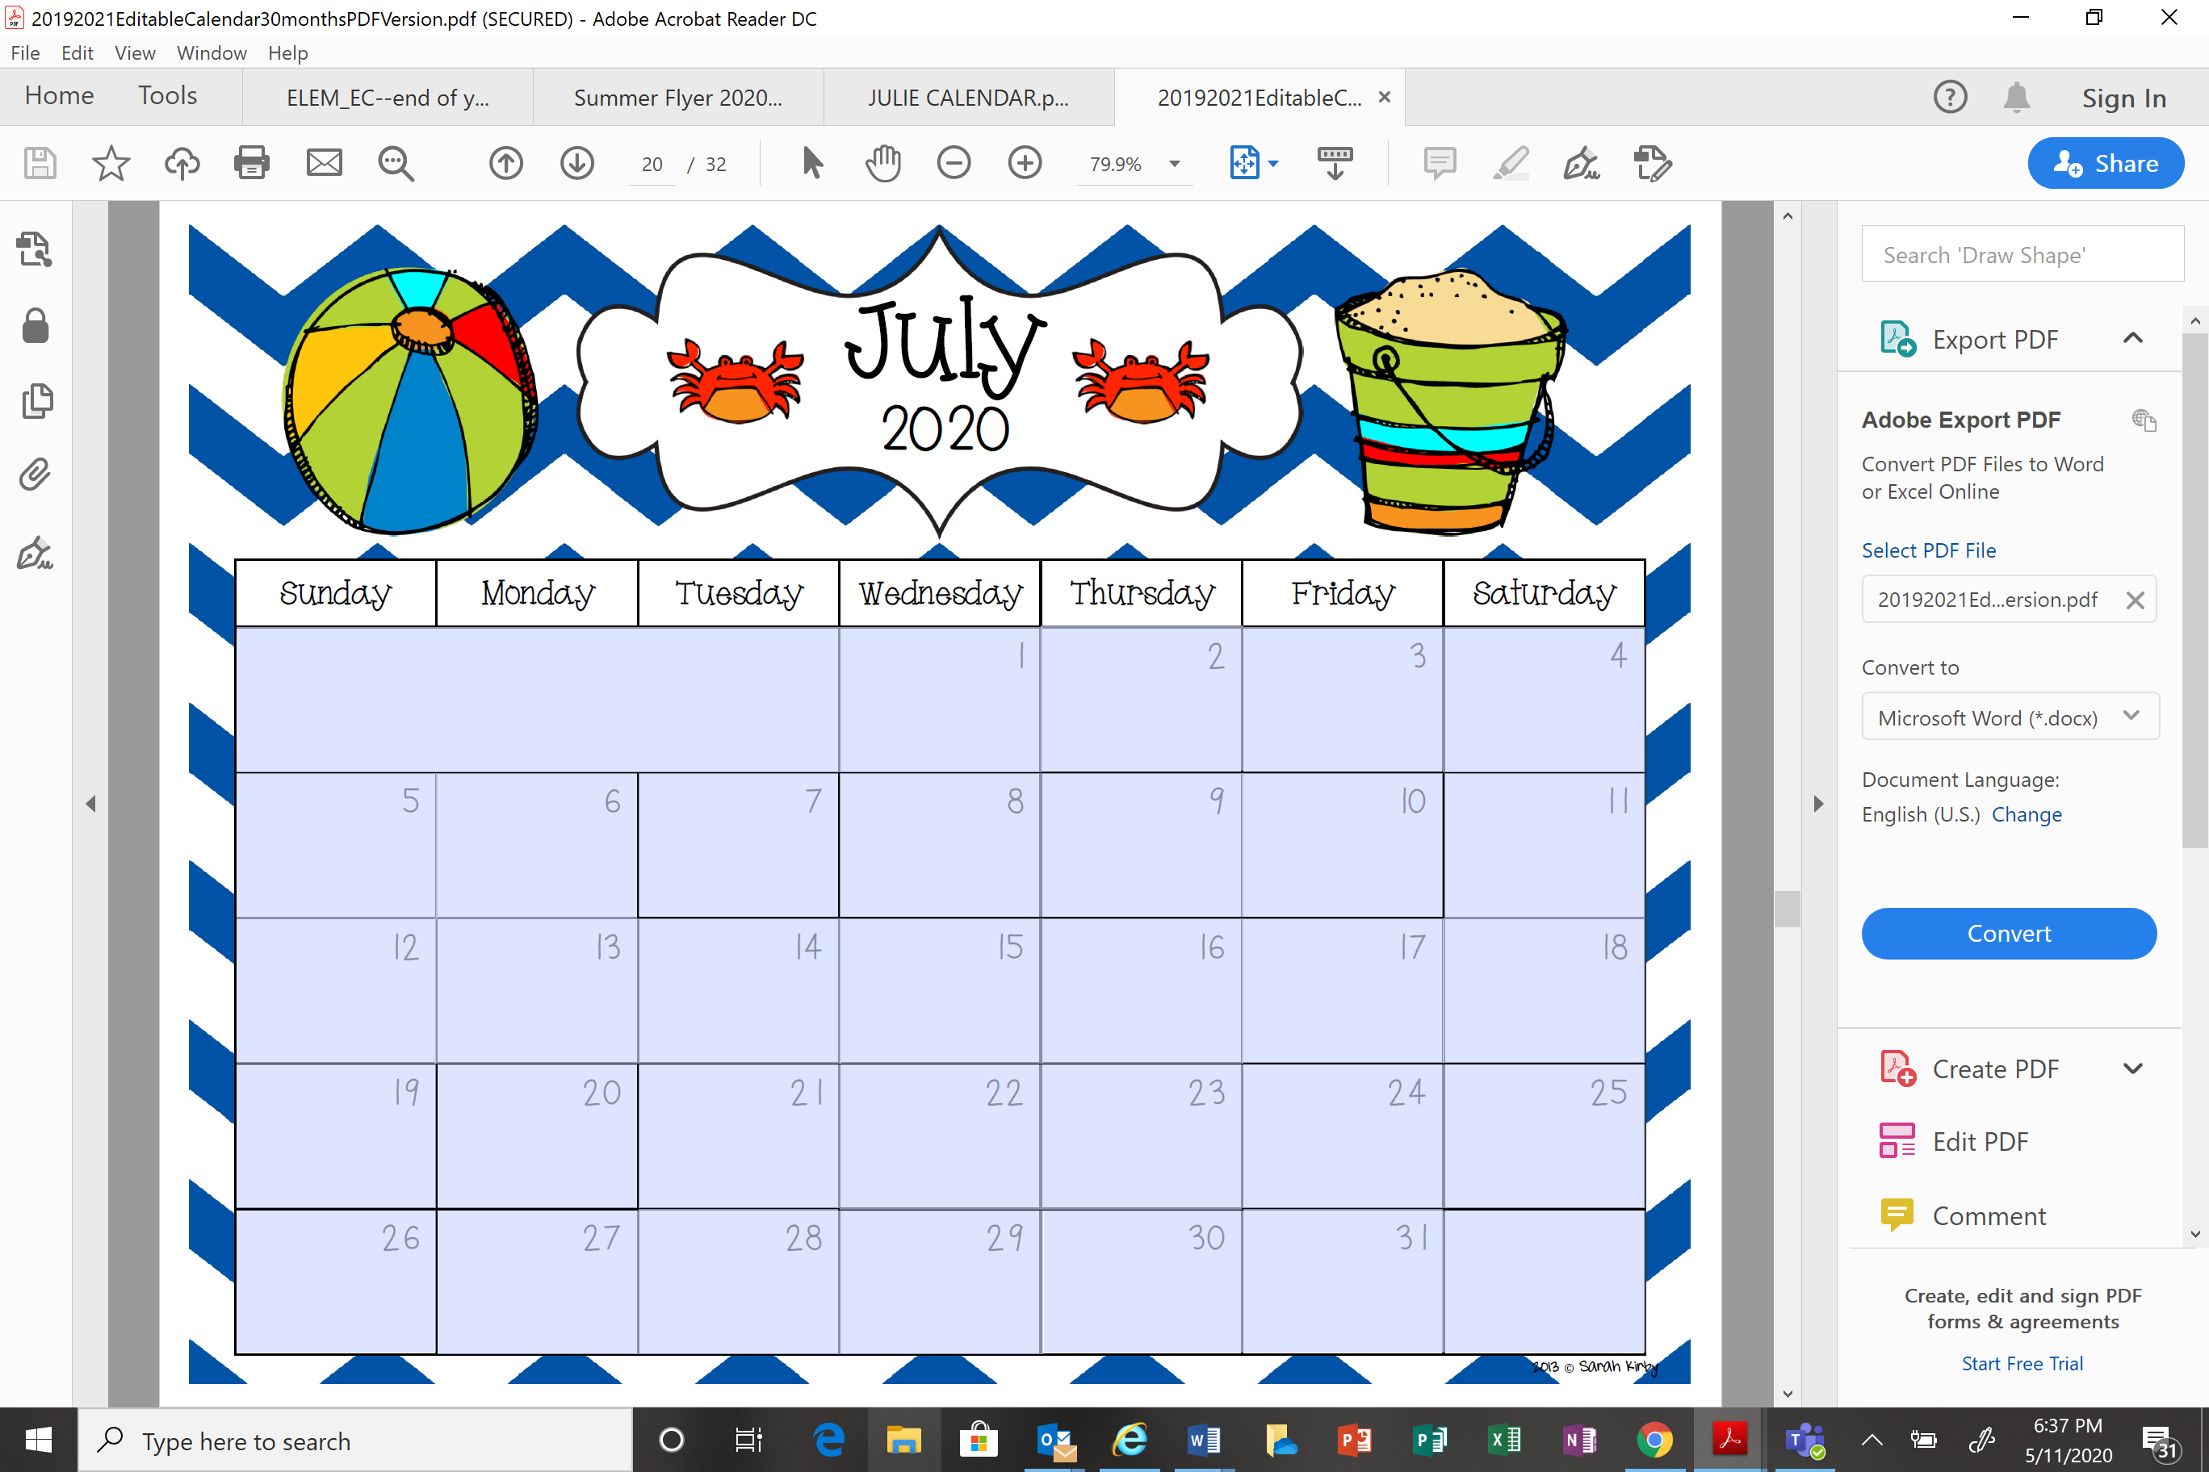
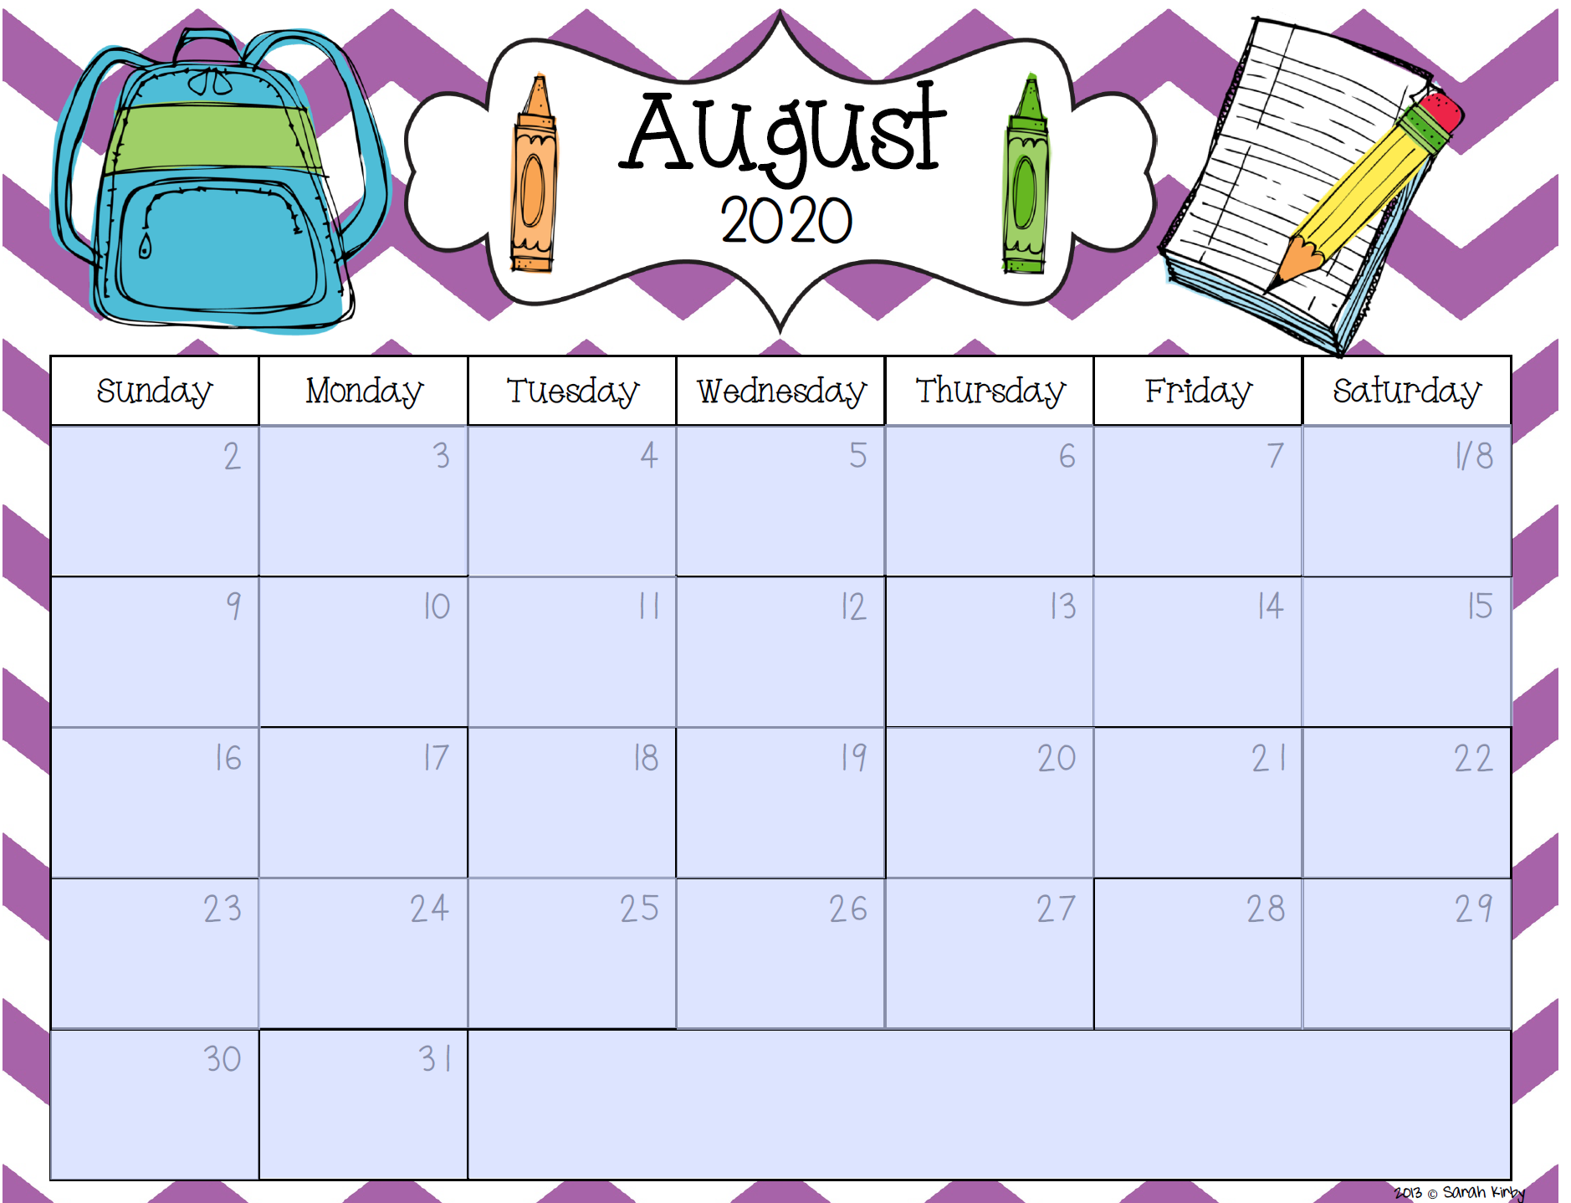

This is going to be an AMAZING summer! We miss you all and we want to KEEP THE LEARNING GOING! Use these calendars and put an M on every day you complete a math activity (you need at least 2 Ms per week). The math activity choices are listed below! Write an R on the date you finish reading a book. If you’re in K-1 you’ll need to read 24 picture books and if you’re in 3-5 you’ll need to read 8 chapter books. If you are in 2nd grade you can choose to do 24 picture books or 8 chapter books. If you complete math AND reading goals, you will be invited to a special event when school begins! Please bring this completed calendar on your first day back to school. We miss you, and you can do this!

REMEMBER, to earn the prize in the fall you will need to complete the READING and MATH goals.
There are 2 ways to meet the math goal.

1.) Complete 2 Dreambox lessons per week

OR

2.) Complete at least 2 items on this list per week, and put an “M” on the calendar to show you completed an activity. You can repeat activities as many times as you’d like!

- Dreambox Lesson

- PBS Kids Math lesson – https://ninenet.pbslearningmedia.org/subjects/mathematics/k-8-mathematics /

- 20 Minutes on an Everyday Math Game-https://connected.mcgraw-hill.com//school/f6m6

- Go to our math website mathclasswithmrskulik.weebly.com and complete one activity at your current or future grade level.

- Complete math page from Evan Moor Summer learning book- if you chose to purchase using this link
https://www.evan-moor.com/search?q=Daily+Summer
And use code: SUM20-047

Questions? Contact the math teachers at jkulik@vp.k12.mo.us or sgarlich@vp.k12.mo.us anytime!

