Activity 1
Birds: A Swimming Machine
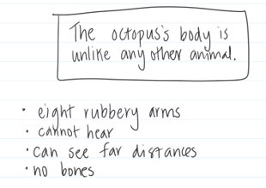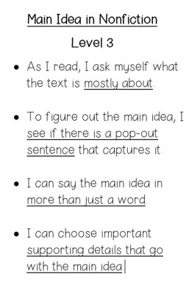
While we read nonfiction this year, we learned how to find the main idea in a passage. We used the "boxes and bullets" organizer to help us organize our thoughts. The main idea goes in the "box" and the details are the bullet points.

Here's an example from our unit:

Today, you are going to read a nonfiction book on True Flix (Username: valleypark / Password: library) .
- Click on "Animal Kingdom" section and then
- Select the "Birds" book.
- Read or listen to the book.
- On page 8, find the main idea of the section "A Swimming Machine".
- You can use the boxes and bullets organizer to help you organize your thoughts

Main Idea:

Activity 2
Nonfiction Boxes and Bullets
Today, you will practice finding the main idea of a nonfiction part of a book again. This time, you are going to get to choose a book about a nonfiction topic that interests you!​
​
First, browse the websites below to find a book or article that you would like to read or have read to you!

True Flix (Username: valleypark Password: library)​
Pebble Go! (Username: vphawks Password: vp1234) ​
Abdo ​ (No usename or password needed)
​
​
Choose one section and write down the main idea of that part of the book. Re-read the rubric to try to make your main idea a level 3!

Book Title:
Which source did you use? True Flux, Pebble Go!, or Abdo
Main Idea:

Activity 3
Super Science Article
Today, you will be reading an article on the coronavirus. After reading the article you will have a worksheet to fill out a summary of the article. There is also a True or False worksheet that is good practice for working on using evidence from the text. You should be able to click on the link for the article to read it and the worksheets will be on your teacher’s websites and they are also attached below.
​
​https://superscience.scholastic.com/etc/classroom-magazines/reader.html?id=46-050120

Activity 3 Worksheet 1.pdf
Activity 3 Worksheet 2.pdf

Type your work here:

